TASK 7: MVP Completion and Git Collaboration
Project: Dockerized Book Issue and Return System
Name: Swar Sawalkar
Roll No.: 23104B0023
Department: CMPN, Fourth Year
Division: C

1. Aim
To complete the Minimum Viable Product (MVP) of the Book Issue and Return System by implementing essential record management functions, role-based status workflow, and a summary dashboard. To demonstrate Git collaboration through a second feature branch, merge conflict creation and resolution, version tagging, and preparation of a release-ready source baseline.
2. Objectives
- Implement create, view, update, and search operations for book records.
- Implement a role-based workflow for book issue and return status.
- Develop a summary dashboard to display important system information.
- Create and merge a second feature branch using Git.
- Demonstrate merge conflict creation and resolution.
- Tag a stable version of the project for release preparation.
3. Theory
The Minimum Viable Product (MVP) is the first usable version of an application containing its essential functions. For the Book Issue and Return System, the MVP allows users to manage book records and track their issue and return status.
Git branching allows developers to implement new features separately without directly modifying the main development branch. When two branches modify the same lines of a file, a merge conflict may occur. The conflict must be resolved before merging.
Git tags identify specific versions of the source code. A release tag helps identify a stable source baseline that can be used for testing, deployment, and future maintenance.
4. Procedure
Step 1: Update the development branch
Open the terminal in GitHub Codespaces and execute:
git switch develop
git pull origin develop
git status
Verify that the working tree is clean before starting new development.
Step 2: Create a second feature branch
Create a separate branch for the remaining MVP functionality.
git switch -c feature/mvp-completion

git branch --show-current
The current branch should display:
feature/mvp-completion
Step 3: Implement the essential MVP functions
Implement and test the following functions in the Spring Boot application.
Function | Description
Create records | Add new book records with appropriate details.
View records | Display the available book records.
Update records | Modify existing book information.
Search records | Search for books using an identifier, title, or other supported field.
Role-based workflow | Control issue and return status updates according to the roles defined in the application.
Summary dashboard | Display available books, issued books, returned books, or other supported summary statistics.
Use the existing controller, service, repository, model, and frontend components as appropriate for the project. Do not claim that a function is implemented unless it is present and tested.
Step 4: Test and commit the changes
Run the project tests:
mvn clean test
If the tests pass, commit the changes:
git add .
git commit -m "Complete MVP features and dashboard"
Step 5: Demonstrate merge conflict creation and resolution
A merge conflict can be demonstrated safely using a separate practice file.
First, create a file and commit it on the feature branch:
echo "MVP baseline" > conflict-demo.txt
git add conflict-demo.txt
git commit -m "Add conflict demonstration file"
Create another branch:
git switch -c feature/conflict-demo
Modify the file and commit:
echo "Feature branch version" > conflict-demo.txt
git add conflict-demo.txt
git commit -m "Update conflict demo from feature branch"
Switch back to the MVP branch and make a different change:
git switch feature/mvp-completion
echo "Development branch version" > conflict-demo.txt
git add conflict-demo.txt
git commit -m "Update conflict demo from MVP branch"
Merge the practice branch:
git merge feature/conflict-demo
If Git reports a conflict, open conflict-demo.txt. Resolve the conflict by keeping the appropriate final content and removing the conflict markers (<<<<<<<, =======, and >>>>>>>).
Then execute:
git add conflict-demo.txt
git commit -m "Resolve merge conflict"
If the merge succeeds without a conflict, do not claim that a conflict was demonstrated. Check the file history and branch changes before proceeding.
Step 6: Push the feature branch
git push -u origin feature/mvp-completion
On GitHub, create a pull request from feature/mvp-completion into develop. Review the changes and merge the pull request after verification.
Step 7: Create a version tag
After confirming that the desired MVP changes are merged into develop, update the local branch:
git switch develop
git pull origin develop
Create a version tag:
git tag -a v1.0.0 -m "MVP release baseline"
git push origin v1.0.0
Verify the tag and repository history:
git tag
git log --oneline --graph --all
git status
Use v1.0.0 only if this is an appropriate version for your project. If the tag already exists, select a new version instead.
5. Workflow Diagram
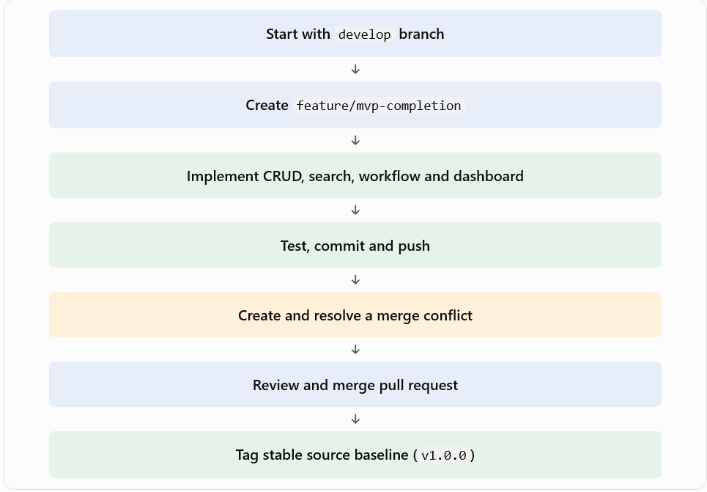
6. Screenshots to include
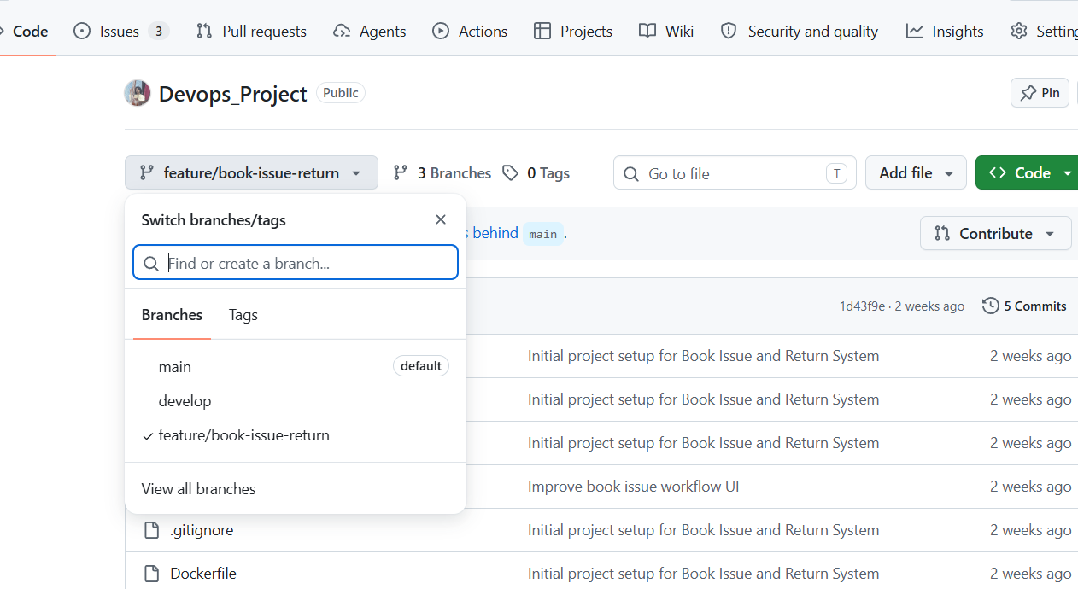
8. Result
The procedure establishes a workflow for completing the Book Issue and Return System MVP, collaborating through Git branches, resolving merge conflicts, and tagging a release baseline. The final result should be recorded after verifying the implemented functions, test results, merged changes, and version tag.
9. Conclusion
The MVP completion process improves the usability of the Book Issue and Return System by covering essential book management operations. Git branching, pull requests, conflict resolution, and version tagging help maintain source code quality and prepare the project for release.

